CS775 – Requirements Engineering
Use Cases - Preserving Digital Art

Abstract
What does the Long term Preservation of Digital Art means?
Human memory fades with time and new technologies overcome the existing technologies. Digital art preservation is availability and accessibility of information on long term basis for the designated community.
http://www.hgladney.com/TDR&TDO.htm
This document aims to cover all the possible use case scenarios related to “Preserving Digital Art”.
After researching and going through various case studies on Digital Art Preservation, I tried to summarize the important and useful information about creation of use cases and successful implementation of digital art work in repositories and related sectors. Relationship between entities is created through inferences, tagging, cataloging etc.
http://www.w3.org/2005/Incubator/lld/wiki/UseCaseReport
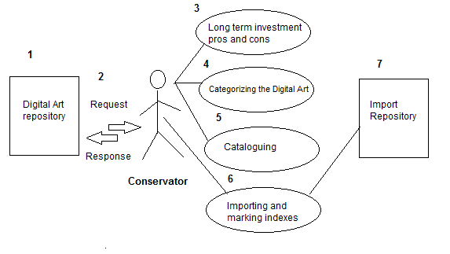

- Use Case Structure
There are many stakeholders involved in the process of digital art preservation such as Art Historians, Museum Donors, Museum Directors, Viewers, Installer, Maintainers, Curators, Artists, and Conservators etc. In this document the 3 main users focused will be Curators, Artists, and Conservators. Brief description about main users:
Curators: Curator is a content specialist who is responsible for a collection and also involved with the interpretation of heritage material.
http://en.wikipedia.org/wiki/Curator
Artists: Person(s) who create the art.
Conservators: Person appointed to protect the record.
http://web.mit.edu/comm-forum/mit7/papers/conserv_dig_art_marchese_MIT7.pdf
The set of use cases based on different case studies, independent research and ideas are described into different classes :
Authority and Permission
Digital Art repository
Cataloging
Citations and References
2.Use Case template
The use case template will be used to analyze the functional and non-functional requirements and to validate the requirement documentation for short and long-term preservation of digital art and maintaining the temperature (if required for certain type of art) in the digital repositories. This document will be helpful understand step by step process to maintain and recreate a digital art upon , when and where required.
As a result, the staff of the preservation department may easily classify the category of digital art to be preserved, process to maintain digital repository, risk planning, artist copyrights and managing stakeholder rights.
Below template may help the preservation staff or technical team to maintain, recreate or validate the required digital art.

Below is type of use case template that can be considered while planning to preserve a digital art.
Step 1: First validate the art to be submitted, maintained, required and recreated by following the prioritized requirements in the attached excel sheet.
Step 2: Below template can be used to handle the use case verification and validation

Use Case ID: | <>
Use Case Name: | <>
Actors: | <>
Description: | <>
Preconditions: | <>
Post conditions: | <>
Positive Flow: | <Step by step flow>
Alternative Flows: | <if any>
Priority: | High
Exceptions: | <if any>
Frequency of Use: | <if any>
Other Requirements: | <if any>
Known Issues: | <if any>
Special Notes | <if any>

